JavaScript Array Methods
(map, filter, reduce, find, includes)

1. map()
map() is used to transform every element in an array and returns a new array.
let numbers = [1, 2, 3, 4];
let doubled = numbers.map(function(num) {
return num * 2;
});
console.log(doubled); // [2, 4, 6, 8]

2. filter()
filter() is used to select elements that match a condition and returns a new array.
let numbers = [1, 2, 3, 4, 5, 6];
let even = numbers.filter(function(num) {
return num % 2 === 0;
});
console.log(even); // [2, 4, 6]

3. reduce()
reduce() combines all elements into a single value such as sum or total.
let numbers = [1, 2, 3, 4];
let sum = numbers.reduce(function(total, num) {
return total + num;
}, 0);
console.log(sum); // 10

4. find()
find() returns the first element that matches a condition.
let numbers = [5, 8, 12, 20];
let result = numbers.find(function(num) {
return num > 10;
});
console.log(result); // 12

5. includes()
includes() checks if a value exists in an array and returns true or false.
let numbers = [1, 2, 3, 4];
let check = numbers.includes(3);
console.log(check); // true
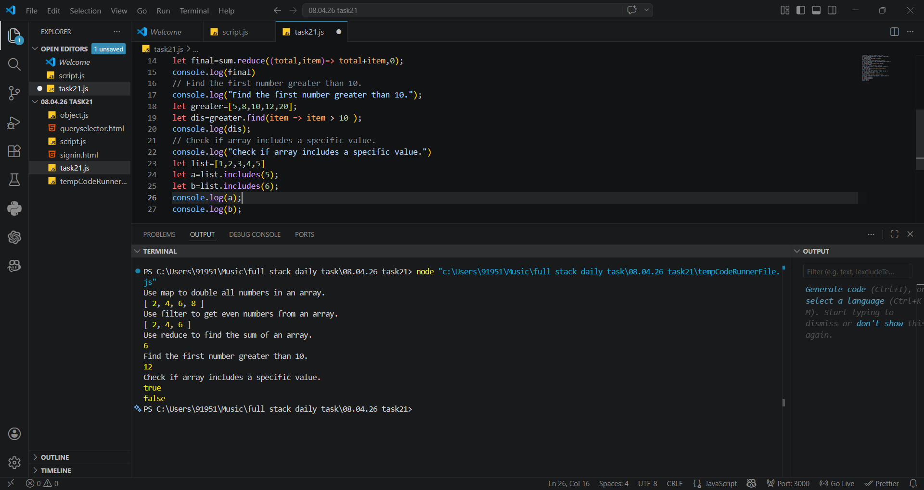
OUTPUT :

